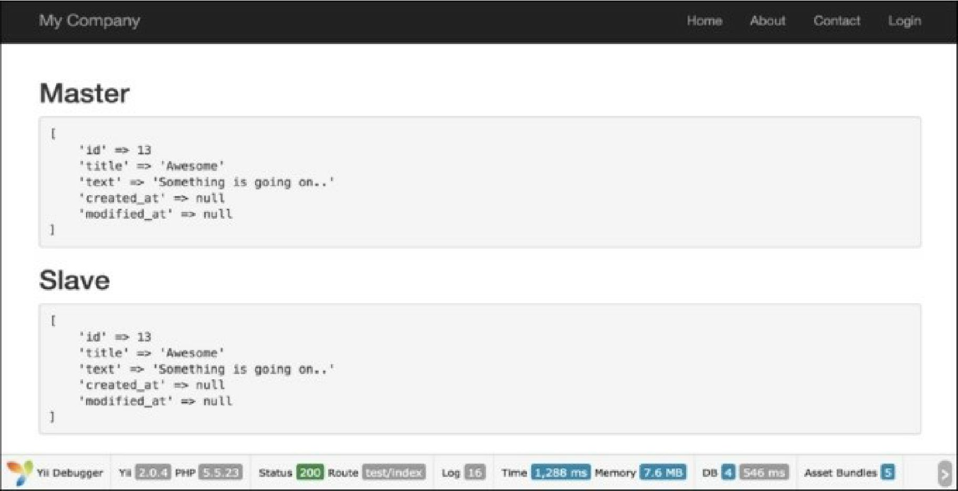

How it works...

Slave servers are used for data reading, whereas the master server is used for writing. After the ActiveRecord model is saved at the master server, new records, replicate to the slave server and then $replModel finds records on it.

There’s more.

The \yii\db\connection component supports load balancing and failover between slaves. When performing a read query for the first time, the \yii\db\connection component will randomly pick a slave and try connecting to it. If the slave is found dead, it will try another one. If none of the slaves are available, it will connect to the master. By configuring a server status cache, a dead server can be remembered so that it will not be tried again during a certain period of time.

See also

For further information, refer to the following URLs:

* [http://www.viiframework.com/doc-2.0/guide-db-dao.html#replication-and-read-write-splitting](http://www.yiiframework.com/doc-2.0/guide-db-dao.html%23replication-and-read-write-splitting)
* [http://dev.mysql.com/doc/refman/5.G/en/replication.html](http://dev.mysql.com/doc/refman/5.6/en/replication.html)
* <http://docs.mongodb.org/manual/tutorial/deploy-replica-set/>
* <http://docs.mongodb.org/manual/tutorial/deploy-replica-set-for-testing/>